Tuesday, 15 September 2026, postcard

Tour of Cluny Abbey, Lunch at a chateau, Trivia

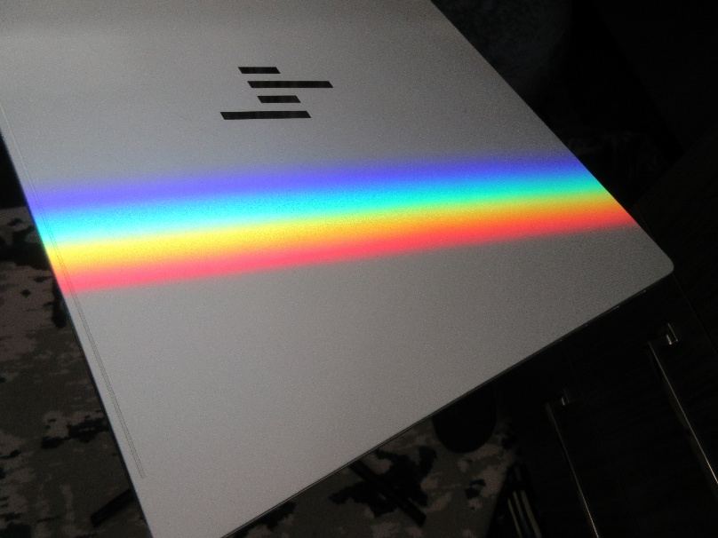
Early every morning, my cabin window treats me to this lovely, perfect rainbow, projected on whatever I leave in its path (today, the closed lid of my laptop).
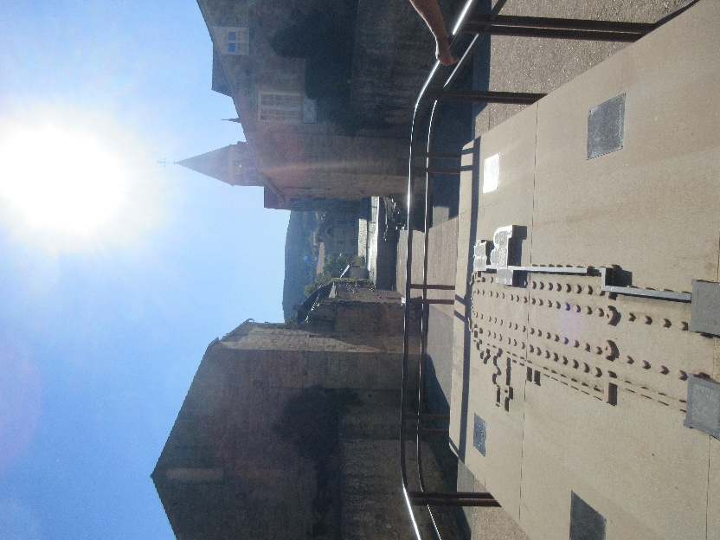
We visited Cluny in 2009 (6/19/2009) and again in 2011 (6/9/2011), and both times we got a more thorough tour than we did this time. We walked by the bishop's palace but didn't have time to go in. We walked over the outline of the abbey church and got to marvel at its amazing length—I tood this photo at what would have been the west entrance, and the pointed tower marks the south transcept, so the apse was well beyond that. It was big—the largest church in Chistendom in its time and (if it were still standing)
in ours as well. It was founded in the 10th century, rose to great power and influence, and began its decline in the 15th century.

Remember in school they told us that human knowledge and scholarship were kept alive through the dark ages in the monasteries? Well, this was the place.

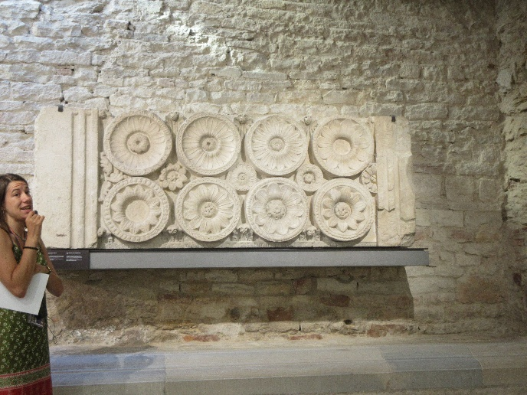
We spent some time in the museum where our guide explained the features of "Clunesian" art and architecture—for example protrayal of flowers "face on," which they never had been before.

Then we enjoyed a concert on an antique forte-piano by a musician and scholar of early keyboard instruments. She was born in Portland, Oregon, but married a Scot who was living in France, and they settled near Cluny.

The old original granary was pointed out to us, but we didn't get to go inside.

But that's an inherent problem of traveling with organized tours. You never get enough time to look at each place thoroughly. All you can do is keep a list of places you'd like to come back and spend more time in. So for fuller descriptions of Cluny, start at Thistle Home Base (http://dthistle.net/), click on 2009 and 2011 and read the entries for the dates I give above.

When we were there in 2011, we also toured the Cluny branch of the French National Equestrian Stud (pretty much across the street from the abbey). We were told even then that it would soon be discontinued, and sure enough, it's now just an equestrian center where you can get riding lessons, board your horse, attend horse shows, etc.

From Cluny, the buses took us to Château Pruzilly, which has been transformed into an event venue. You can book it for weddings and other special occasions, and they hold disco nights in the former wine cellar every Saturday.

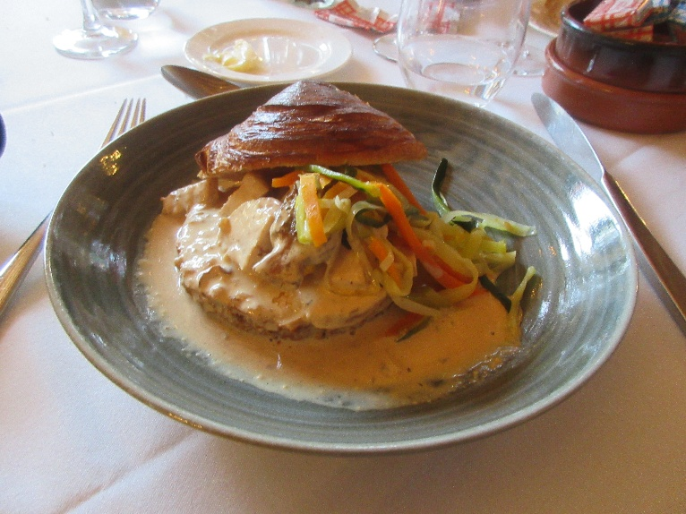
They served us a lovely lunch of chicken in morel cream sauce on "brioche feuilleté" with shredded veggies.

Back on the ship, we had a particularly delicious dinner that started with foie gras
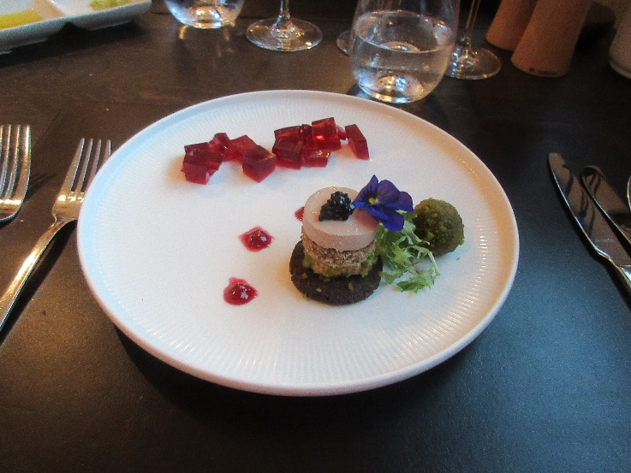
garnished with red current jelly

and continued with rare roasted breast of duck.
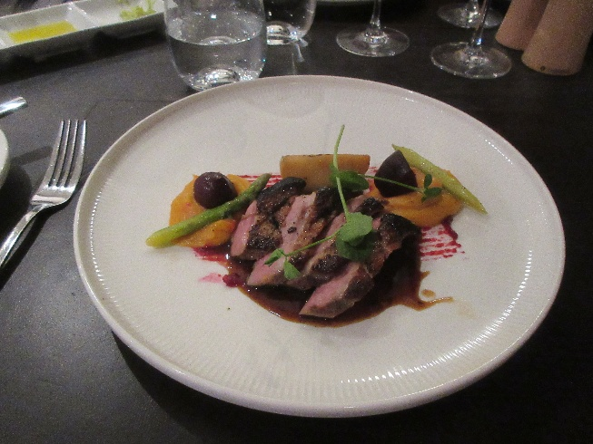

But the after-dinner trivia quiz was a disappointment—totally disorganized.

